- Listed the available API services using command

gcloud services list --available

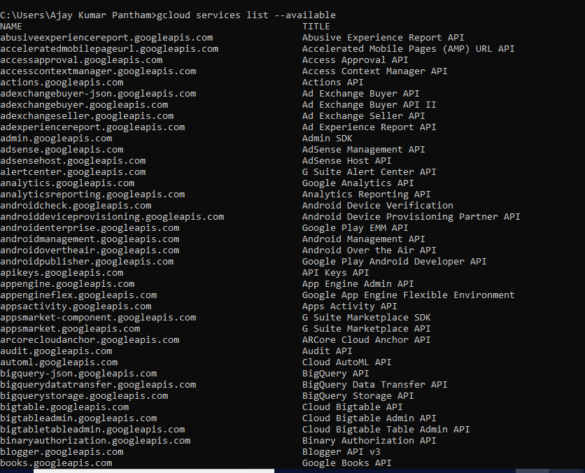

- Listed the enabled API services using command

gcloud services list

